Q.1 What is the corresponding MIPS Assembler output for the following C ++ statement:
W = (k + l) – (m + n)?

Q.2 For an I-Format MIPS instruction, what are the maximum bounds which the instruction-stored constant may take?

Q.3 Specify the registers of the MIPS microprocessor and their uses?

Q.4 Suppose branch destination is further away than can be captured by 2 bytes, what the assembler do to solve this problem? Give an example?

Q.5 What are the fundamental and basic RISC guideline design principles in MIPS-based computer architecture?

Q.8 Convert 7fff fffe_{hex} to binary and decimal.

Q.10 This C version of a case statement is called a switch statement. The following C code chooses among four alternatives depending on whether k has the value 0, 1, 2, or 3.
switch (k) {
case 0:f = i - j; break; /* k = 0 */
case 1:f = g - h; break; /* k = 1 */
case 2:f = g + h; break; /* k = 2 */
case 3:f = i + j; break; /* k = 3 */
}
Assume the six variables f through k correspond to six registers $s0 through $s5 and that register $t2 contains 4. What is the corresponding MIPS code?
[Hint: use the switch variable k to index a jump address table, and then jump via the value loaded. We first test k to be sure it matches one of the cases (0 ≤ k ≤ 3); if not, the code exits the switch statement.]

Q.10 This C version of a case statement is called a switch statement. The following C code chooses among four alternatives depending on whether k has the value 0, 1, 2, or 3.
switch (k) {
case 0:f = i - j; break; /* k = 0 */
case 1:f = g - h; break; /* k = 1 */
case 2:f = g + h; break; /* k = 2 */
case 3:f = i + j; break; /* k = 3 */
}
Assume the six variables f through k correspond to six registers $s0 through $s5 and that register $t2 contains 4. What is the corresponding MIPS code?
[Hint: use the switch variable k to index a jump address table, and then jump via the value loaded. We first test k to be sure it matches one of the cases (0 ≤ k ≤ 3); if not, the code exits the switch statement.]

Q.11 Write a procedure, StrLen, in MIPS assembly language. The procedure should take a single argument that is a pointer to a null-terminated string in register $a0. The StrLen procedure should find the length of this string in characters and returns the length in register $v0. For example, if the argument to StrLen points to the string “imbibe” then the return value will be 6.

Q.12 (a) Translate the following assembly code back to equivalent C code:
addi $t0, $zero, 1 # i = 1
addi $v0, $zero, 1 # v = 1
Loop: sle $t1, $t0, $a0 # set $t1 to 1 if (i < arg)
beq $t1, $zero, Exit # exit loop if (i >= arg)
mul $v0, $v0, $t0 # v *= i
addi $t0, $t0, 1 # i ++
j Loop # loop

(b) What function does the above code perform?

Q.13. Add a comment to each statement of the following MIPS assembly procedure :

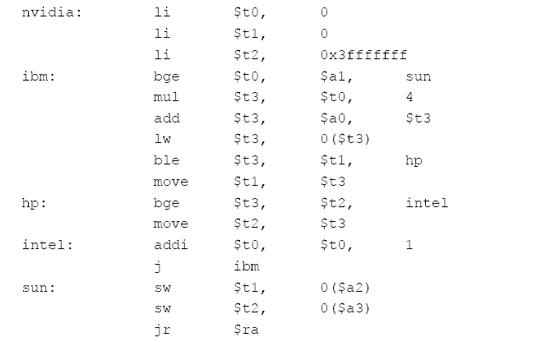
Describe the computation performed by this code.
Q.14.(a) Write a recursive procedure binomial(n, m) (in C) where n and m are 32 bit positive integers to compute the binomial coefficient 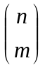 using the formula 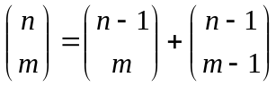. Make sure that you provide appropriate exit conditions.

(b) Translate your code C for binomial(n, m) into MIPS assembly code.

Q.15. Shown below are five single precision floating-point integers in the IEEE 754 format. Arrange them from the smallest to the largest.

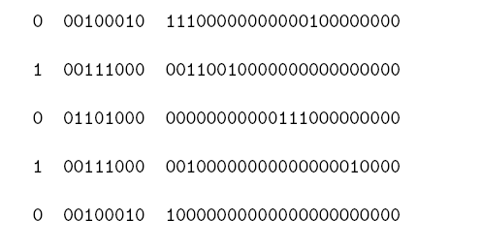
Q.16.

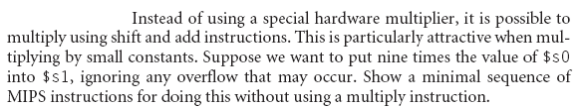

Q.17. Write a code segment in MIPS assembly language that sets $t0 to 1 (0) if the architecture uses big-endian (little-endian) notation.

